Ensemble to RabbitMQ

Java Client Quick Start Guide

# Software versions

## Server

|  |  |
| --- | --- |
| OS | Windows Server 2012 R2 x64 |
| Erlang | OTP 19.1 |
| RabbitMQ Server | 3.6.5 |
| RabbitMQ Java Client | 3.6.5 |

## Client

|  |  |
| --- | --- |
| OS | Windows Server 2012 R2 x64 |
| Java | JDK SE 8u111  JRE SE 8u111 |
| RabbitMQ Java Client | 3.6.5 |
| Ensemble | 2016.2.0.736.0 |

# RabbitMQ

## Install server

Download and run the Erlang Windows Binary File.

Download and install the RabbitMQ Server.

<http://www.rabbitmq.com/install-windows.html>

### Open port 5672 on server firewall

5672 is the default non-SSL port the RabbitMQ server listens for AMQP connections.

If not already configured during the RabbitMQ Server installation then open the Windows Firewall with Advanced Security management console:

Control Panel > Administrative Tools > Windows Firewall with Advanced Security

Add a new Port Inbound Rule:

|  |  |
| --- | --- |
| Protocol | TCP |
| Port | 5672 |

And any other ports required for this installation.

## Install client

Install client on both the server hosting the RabbitMQ Server and a machine acting as a remote client.

Download and install the Java JDK.

Set and check JAVA_HOME, example:

System > Advanced system settings > Environment Variables…

Variable name: **JAVA_HOME**

Variable value: **C:\Program Files\Java\jdk1.8.0_111**

C:\>echo %JAVA_HOME%

C:\Program Files\Java\jdk1.8.0_111

Add the JDK bin folder to the system PATH, example:

System > Advanced system settings > Environment Variables…

Variable name: Path

Variable value: %SystemRoot%;%SystemRoot%\system32;

%SystemRoot%\System32\Wbem;%SYSTEMROOT%\System32\WindowsPowerShell\v1.0\;**C:\Program Files\Java\jdk1.8.0_111\bin**

Download, unzip and copy the RabbitMQ Java Client files to a folder:

C:\rabbitmq-java-client-bin-3.6.5\commons-cli-1.1.jar

C:\rabbitmq-java-client-bin-3.6.5\commons-io-1.2.jar

C:\rabbitmq-java-client-bin-3.6.5\junit.jar

…

C:\rabbitmq-java-client-bin-3.6.5\stresspersister.sh

## RPC local quick test

Local to RabbitMQ Server to facilitate confidence testing.

Download RabbitMQ Performance Testing Tool jar file:

<http://central.maven.org/maven2/com/rabbitmq/perf-test/1.0.1/perf-test-1.0.1.jar>

Copy the jar file to the RabbitMQ Java Client folder:

C:\rabbitmq-java-client-bin-3.6.5\perf-test-1.0.1.jar

More details available at:

<https://www.rabbitmq.com/java-tools.html>

<https://github.com/rabbitmq/rabbitmq-perf-test>

### Notes:

The following are defaulted to:

|  |  |
| --- | --- |
| host name | "amqp://localhost" |
| user name | “guest” |
| Password | “guest” |
| port number | 5672 |
| Vhost | “/” |

### Run HelloServer example

Open a command prompt, navigate to the RabbitMQ Java client folder and execute:

*RabbitMQ Java client path*>runjava com.rabbitmq.examples.HelloServer

Example:

Windows:

C:\rabbitmq-java-client-bin-3.6.5>runjava com.rabbitmq.examples.HelloServer

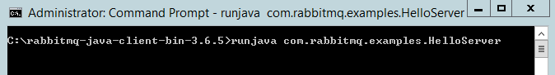

Unix:

$ sh runjava.sh com.rabbitmq.examples.HelloServer

### Run HelloClient example

Open a separate command prompt, navigate to the Java client folder and execute:

*Java client path*>runjava com.rabbitmq.examples.HelloClient

Example:

C:\rabbitmq-java-client-bin-3.6.5>runjava com.rabbitmq.examples.HelloClient

C:\rabbitmq-java-client-bin-3.6.5>runjava com.rabbitmq.examples.HelloClient "Tony"

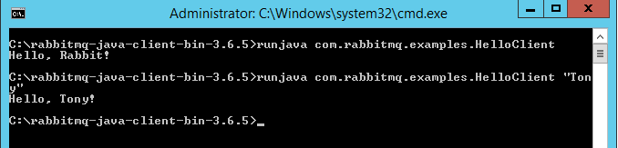

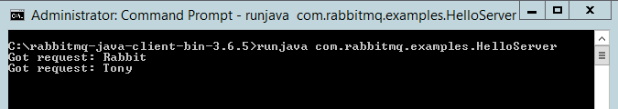

Unix:

$ sh runjava.sh com.rabbitmq.examples.HelloClient

Hello, Rabbit!

$ sh runjava.sh com.rabbitmq.examples.HelloClient "Tony"

Hello, Tony!

### Monitor queues

Open a separate command prompt, navigate to the *sbin* folder in the RabbitMQ server folder and execute:

*RabbitMQ Server path>*\sbin\rabbitmqctl list_queues

Example:

C:\Program Files\RabbitMQ Server\rabbitmq_server-3.6.5\sbin>rabbitmqctl list_queues

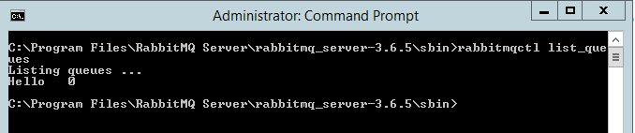

Unix:

$ ./rabbitmqctl list_queues

Listing queues ...

Hello 0

## RPC remote quick test

Remote to RabbitMQ server to facilitate confidence testing across network.

### Notes:

The following are defaulted to:

|  |  |
| --- | --- |
| user name | “guest” |
| Password | “guest” |
| port number | 5672 |
| Vhost | “/” |

"guest" user can only connect via localhost:

<https://www.rabbitmq.com/access-control.html>

### Run HelloServer example

On the remote machine; open a command prompt, navigate to the RabbitMQ Java client folder and execute:

*RabbitMQ Java client path*>runjava com.rabbitmq.examples.HelloServer “*host*”

Example:

Windows:

C:\rabbitmq-java-client-bin-3.6.5>runjava com.rabbitmq.examples.HelloServer "amqp://WIN-UK0KESAK7LB"

Unix:

$ sh runjava.sh com.rabbitmq.examples.HelloServer

### Run HelloClient example

On the remote machine; open a separate command prompt, navigate to the Java client folder and execute:

*Java client path*>runjava com.rabbitmq.examples.HelloClient “*message*” “*host*”

Example:

Windows:

C:\rabbitmq-java-client-bin-3.6.5>runjava com.rabbitmq.examples.HelloClient "Tony" "amqp://WIN-UK0KESAK7LB"

Unix:

$ sh runjava.sh com.rabbitmq.examples.HelloClient "Tony" "amqp://WIN-UK0KESAK7LB"

Hello, Tony!

### Monitor queues

On the RabbitMQ Server server; open a separate command prompt, navigate to the *sbin* folder in the RabbitMQ server folder and execute:

*RabbitMQ Server path>*\sbin\rabbitmqctl list_queues

Example:

Windows:

C:\Program Files\RabbitMQ Server\rabbitmq_server-3.6.5\sbin>rabbitmqctl list_queues

Unix:

$ ./rabbitmqctl list_queues

Listing queues ...

Hello 0

# Ensemble Object Gateway

## Create Java Object Gateway definition

Navigate to the Object Gateways page in the Management Portal:

System > Configuration > Connectivity > Object Gateways

and select Create New Gateway.

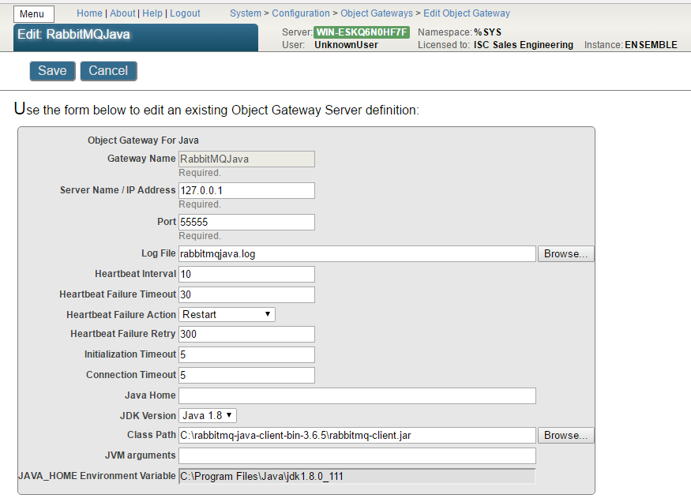

## Start instance of gateway

You can start the Java Gateway server in one of the following ways:

* Manually, by selecting the Start link of a previously configured gateway (see below)
* Manually, by calling the business service StartGateway method
* Manually, by entering a command at the Terminal command prompt
* Automatically, by adding a Java Gateway business service to the production
  + The Java Gateway server starts when the production starts

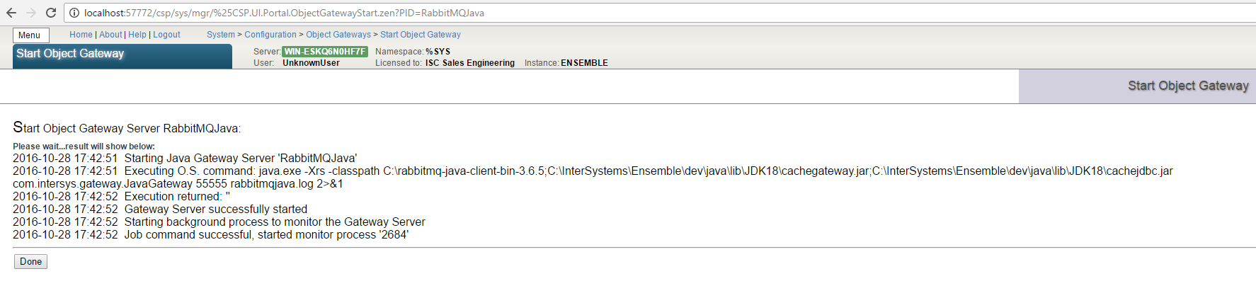

# proxy class

The object gatew```

ay provides a proxy class mechanism to execute, in this example, Java code, from within Ensemble.

## RabbitMQ Java wrapper class

It is usually not practical to import a complete library, so the recommendation is to create a wrapper class that provides a simplified, subset of the required functionality.

### Create a Java source file

Example: *<root folder>\com\myorgname\rabbitmq\Wrapper.java*

package com.myorgname.rabbitmq;

import com.rabbitmq.client.ConnectionFactory;

import com.rabbitmq.client.Connection;

import com.rabbitmq.client.Channel;

import com.rabbitmq.client.QueueingConsumer;

public class Wrapper {

public void sendMsg(String hostName, String queueName, byte[] msg) throws Exception {

ConnectionFactory factory = new ConnectionFactory();

factory.setHost(hostName);

Connection connection = factory.newConnection();

Channel channel = connection.createChannel();

channel.queueDeclare(queueName, false, false, false, null);

channel.basicPublish("", queueName, null, msg);

channel.close();

connection.close();

}

public int readMsg(String hostName, String queueName, byte[] msg) throws Exception {

ConnectionFactory factory = new ConnectionFactory();

factory.setHost(hostName);

Connection connection = factory.newConnection();

Channel channel = connection.createChannel();

channel.queueDeclare(queueName, false, false, false, null);

QueueingConsumer consumer = new QueueingConsumer(channel);

channel.basicConsume(queueName, true, consumer);

QueueingConsumer.Delivery delivery = consumer.nextDelivery();

int len = delivery.getBody().length;

System.arraycopy(delivery.getBody(),0,msg,0,len);

channel.close();

connection.close();

return len;

}

}

### Compile the wrapper class

Compile the class using for example:

javac -verbose -cp C:\rabbitmq-java-client-bin-3.6.5\rabbitmq-client.jar com\myorgname\rabbitmq\Wrapper.java

Example output:

C:\rabbitmq-java-proxy-3.6.5>javac -verbose -cp C:\rabbitmq-java-client-bin-3.6.

5\rabbitmq-client.jar com\myorgname\rabbitmq\Wrapper.java

[parsing started RegularFileObject[com\myorgname\rabbitmq\Wrapper.java]]

[parsing completed 30ms]

[search path for source files: C:\rabbitmq-java-client-bin-3.6.5\rabbitmq-client

.jar]

…

[loading ZipFileIndexFileObject[C:\rabbitmq-java-client-bin-3.6.5\rabbitmq-clien

t.jar(com/rabbitmq/client/AMQP$BasicProperties.class)]]

[wrote RegularFileObject[com\myorgname\rabbitmq\Wrapper.class]]

[total 631ms]

### Package the class/es in a jar file

Create a jar using for example:

jar cvf myorgname-rabbitmq-wrapper.jar com\myorgname\rabbitmq\Wrapper.class

Example output:

C:\rabbitmq-java-proxy-3.6.5>jar cvf myorgname-rabbitmq-wrapper.jar com\myorgnam

e\rabbitmq\Wrapper.class

added manifest

adding: com/myorgname/rabbitmq/Wrapper.class(in = 1938) (out= 899)(deflated 53%)

### Copy the jar file to the RabbitMQ Java client install folder

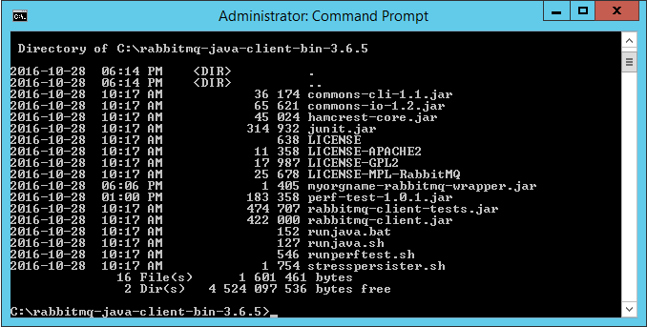

# Ensemble proxy class

## Import the wrapper into Ensemble

* Open the Java Gateway Wizard in Studio:

Tools > Add-Ins > Java Gateway Wizard

* Select Jar File and enter the path and name of the wrapper jar file
* Specify the Java Gateway server name or IP address and its port number
* Select Next

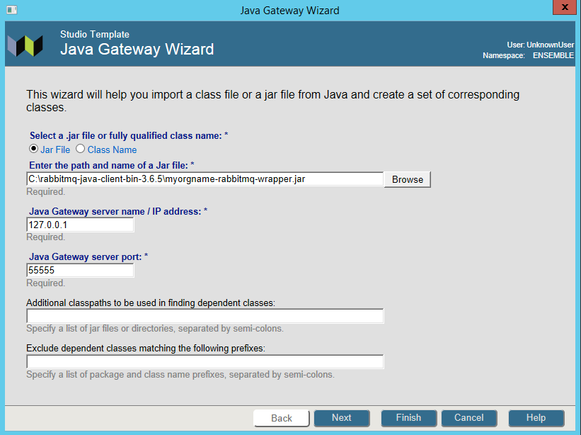

* Select the Wrapper class
* Select Finish

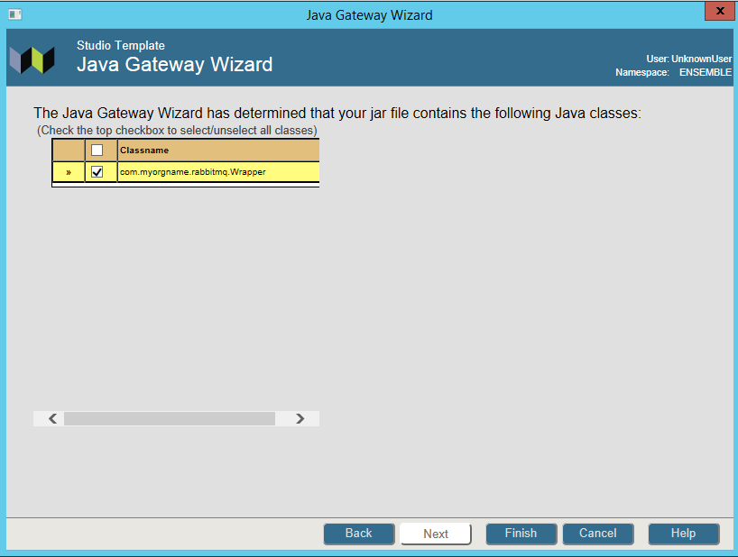

Example result of an import:

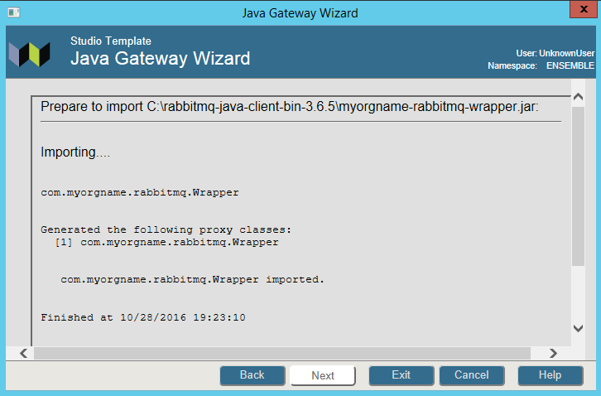

Note the proxy classes imported:

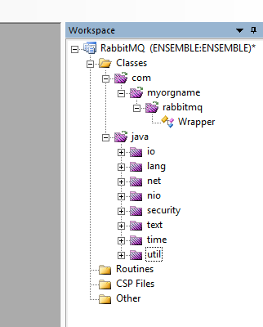

# Use the proxy classes in your application

## Create a utility class to test connectivity to the RabbitMQ server

Class RabbitMQ.Java.HelloWorld Extends %RegisteredObject

{

Parameter CLASSPATH = "C:\rabbitmq-java-client-bin-3.6.5\myorgname-rabbitmq-wrapper.jar";

Parameter HOST = "localhost";

Parameter QUEUE = "hello";

/// s sc=##class(RabbitMQ.Java.HelloWorld).SendMsg()

ClassMethod SendMsg(pMsg = "Hello from Ensemble!") As %Status

{

#dim tGateway as %Net.Remote.Gateway

#dim tException as %Exception.AbstractException

Set tSC=$$$OK

Try {

Set tGateway=..Connect()

Set tRabbitMQWrapper=##class(com.myorgname.rabbitmq.Wrapper).%New(tGateway)

//*** Do not use this syntax. It does not work! ***

// Set tByteStream=##class(%Library.GlobalBinaryStream).%New("Hello World!")

// ************************************************

Set tByteStream=##class(%Library.GlobalBinaryStream).%New()

Set tSC = tByteStream.Write(pMsg)

Do tRabbitMQWrapper.sendMsg(..#HOST,..#QUEUE, tByteStream)

Write !,"Sent message via "_tByteStream.Read()

Set tSC=tGateway.%Disconnect()

} Catch tException {

Set tSC = tException.AsStatus()

}

Quit tSC

}

/// s sc=##class(RabbitMQ.Java.HelloWorld).ReadMsg()

ClassMethod ReadMsg(pMsgLen = 32000) As %Status

{

#dim tGateway as %Net.Remote.Gateway

#dim tException as %Exception.AbstractException

Set tSC=$$$OK

Try {

Set tGateway=..Connect()

Set tRabbitMQWrapper=##class(com.myorgname.rabbitmq.Wrapper).%New(tGateway)

Set tReadStream=##class(%GlobalBinaryStream).%New()

// we need to 'reserve' a number of bytes since we are passing the stream

// by reference (Java's equivalent is byte[] ba = new byte[max];)

For i=1:1:pMsgLen Do tReadStream.Write("0")

Set tBytesRead=tRabbitMQWrapper.readMsg(..#HOST,..#QUEUE, .tReadStream)

Write tReadStream.Read(tBytesRead),!

Write "Bytes Read: ",tBytesRead,!

Set tSC=tGateway.%Disconnect()

} Catch tException {

Set tSC = tException.AsStatus()

}

Quit tSC

}

ClassMethod Connect(pPort As %Integer = 55555, pHost As %String = "127.0.0.1") As %Net.Remote.Gateway

{

// connect to current namespace, use 2 second timeout

Set tSC=$$$OK,tNamespace=$zu(5),tTimeout=2

Set tClassPath=##class(%ListOfDataTypes).%New()

Do tClassPath.Insert(..#CLASSPATH)

// get a connection handle and connect

Set tGateway=##class(%Net.Remote.Gateway).%New()

Set tSC=tGateway.%Connect(pHost,pPort,tNamespace,tTimeout,tClassPath)

If tSC'=$$$OK {

Write $system.OBJ.DisplayError(tSC)

Set tGateway=""

}

Quit tGateway

}

### Test the utility class

